To Add a Preference
Updated on 1/31/2026
Add the Preference Using EmpowerWin
Using EmpowerWin logged into EmpowerNET_Main, use Admin > Preferences > Preferences to add the new preference.
Add the Preference to the Prefernces.vb Class in Visual Studio
In Visual Studio, go to
\Main\API\Empower\Configuration\Preferences
and add the preference to Preferences.vb in alphabetical order.

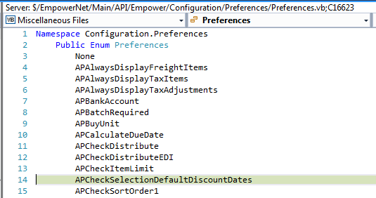

Create Standard EmpowerWin Scripts
In Visual Studio, open the Release solution. Start the Release Solution and click only the Update Scripts checkbox.
When this is finished, the new Preference is in the standard script:
Database\Empower Maintenance\Scripts\ 07_10_insert_default_values.sql
Open the script file in VS and Find the new Preference.

Examples of Referencing a Preference in VS code

Configuration.Preferences.Preferences.APPayUnit.GetPreferenceValue

Configuration.Preferences.Preferences.APCheckSelectionDefaultDiscountDates.GetPreferenceValue

